

**WHITE PAPER**

**DOCUMENTS** **FOR OFFICE MANAGEMENT SYSTEM**

**PREPARED BY**

**NAHID HASAN SHUVO MEHEDI HASAN FARAJ**

**ID:171-35-2056 ID:171-35-2056**

**Department of Software Engineering**

**Submission Date:16.12.2018**

# Table of Contents

1. **Overview ...................................................................................................... 3**
2. **Industry Analysis .......................................................................................... 3**
3. **The Office Management Concept ................................................................ 4**
4. **The Office Management Platform ................................................................ 6**
5. **Value Added Features ............................................................................... 8**
6. **Customizable User Experience ................................................................ 9**
7. **Deployment Model ............................................................................... 10**
8. **Summary ................................................................................................. 12**

## Overview

E-Office is a platform that enables b to stay competitive by quickly and securely adapting to new customer demands. In this paper, we’ll address how office can future-proof their investments in core office systems while cost-effectively integrating new office management services as the market evolves.

### Industry Analysis

**Users expect to have secure access to their financial information and related financial tools everywhere, anytime:** 1.their financial information could be a office management, the status of an order on the purchase of a security or historical information about previous financial transactions. Users expect to have highly secure access to this information via software running on a digital channel of their choice, be that a mobile or tablet application, a wearable, a voice activated device or even an IoT device. Users expect these channels to facilitate anything from contactless payments and credit scoring, to account opening or loan origination.

**Office are expected to have an Open API strategy.** From a regulatory perspective, the Payment Services Directive (PSD2) in Europe is forcing office to expose core banking features related to authentication, authorization and payments to third parties, merchants and competing issuing banks via Office Management APIs (Application Program Interfaces).2 In the United States the OCC FinTech Charter is creating a framework within which disruptive FinTech start-ups can compete with compliant deposit taking institutions. Banks are being pushed to embrace the FinTech disruption through API integrations or risk becoming less relevant in the marketplace.

**3 Enterprise software engineering is expensive and complex,** especially when it comes to building mobile applications connected to cloud services and banking systems.

**4 Most core banking systems are old and not easily extensible** and software engineering teams within office and credit unions are focused on operational roadmaps and don’t have the capacity or sometimes the skill to build emerging technology solutions for their customers and integrate with disruptive FinTech companies.

### The E-Office Concept

The industry needs an open office platform which helps office quickly and cost effectively meet the demands of the market and the regulators in a secure and customizable way. The conceptual model below is very rudimentary view of where the E-office Platform would live in terms of the industry actors.

At its core, the E-office Platform abstracts the complexities and legacy inherent in popular core office systems to help office better service individuals, merchants and third parties. More specifically, individuals, merchants and third parties want access to core office functionality in a modern way.

In the case of individuals and merchants, they would typically access this functionality via a digital user experience of some kind, while value adding third parties would want to access this functionality via modern, compliant APIs. The typical set of functionalities referred to here that resides within core banking platforms includes items such as authentication, registration, account information, transaction history, payments, transfers and settings.

Access to this set of functionalities needs to be highly secure such that each transaction originating from a digital channel or third-party system is secured with a once-use cryptographic token issued by the platform.

If we expand on the above conceptual model a little further, we see that the E-Office Platform needs to address the following four main requirements:

* **User Experience:** Represents the way individuals and merchants would typically access financial services functionality.

**Core Banking:** Represents the abstraction of common functions within popular Core Banking systems currently in use by banks and financial institutions.

* **FinTech Disruption:** Represents the ability for third parties to easily integrate into Core Banking platforms.
* **Security:** Ensures that individuals, merchants and third parties can access core banking functionality in a highly secure and compliant manner.

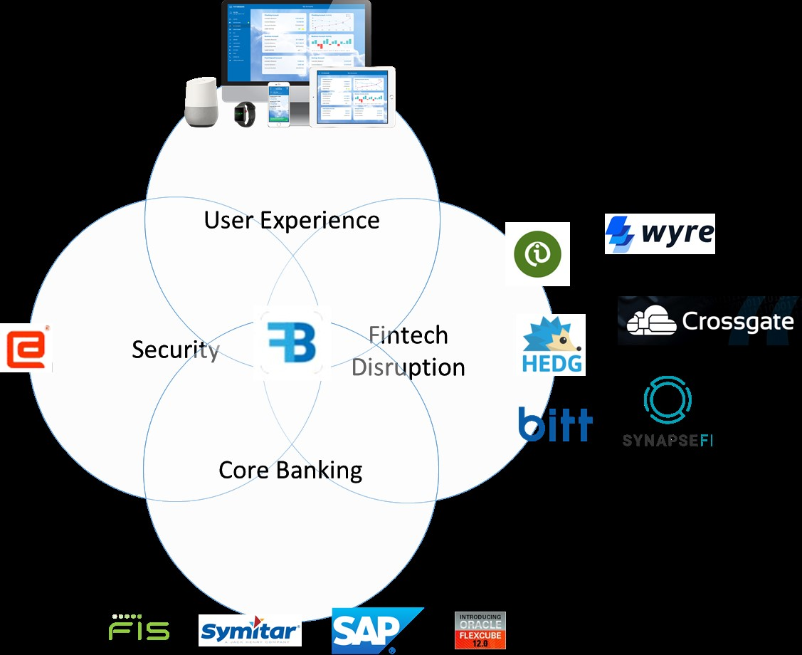

Figure : E-Office Platform Conceptual Model Expanded

The diagram above expands slightly on each of these concepts to provide context for each. For example, from a User Experience perspective, the E-Office Platform is designed to support popular web, mobile, tablet, wearable and voice form factor technologies.

From a Core Office perspective, the platform is designed to maintain a growing library of adaptors into the most ubiquitous core banking systems provided by the likes of FIS, Symitar, SAP, Oracle and Temenos to name a few.

For Security, E-Office uses unique asymmetrically encrypted HSM tokens provided by Entersekt’s HSM to secure each transaction through the platform.

In terms of support for FinTech Disruption, E-office exposes a customizable event driven API and SDK architecture for easy integration between core banking systems and third parties for services like innovative payment rails, loyalty systems, wealth management services and more.

In future we see each E-Office Platform instance to have the ability to host its own a plug-in marketplace where platform developers can register their disruptive products and make them seamlessly available to digital channel users.

## The Future Bank Platform

Secure. Compliant. Simple. Flexible.

The ECBank Platform is a secure and customizable Mobile, Web and Microservices API platform that integrates with popular core banking systems. The platform uses unique asymmetrically encrypted HSM tokens provided by Entersekt’s HSM to secure each transaction through the platform. The platform exposes a customizable event driven API and SDK architecture for easy integration into third parties, merchants and individuals. The diagram below is an illustration of the high-level platform architecture.

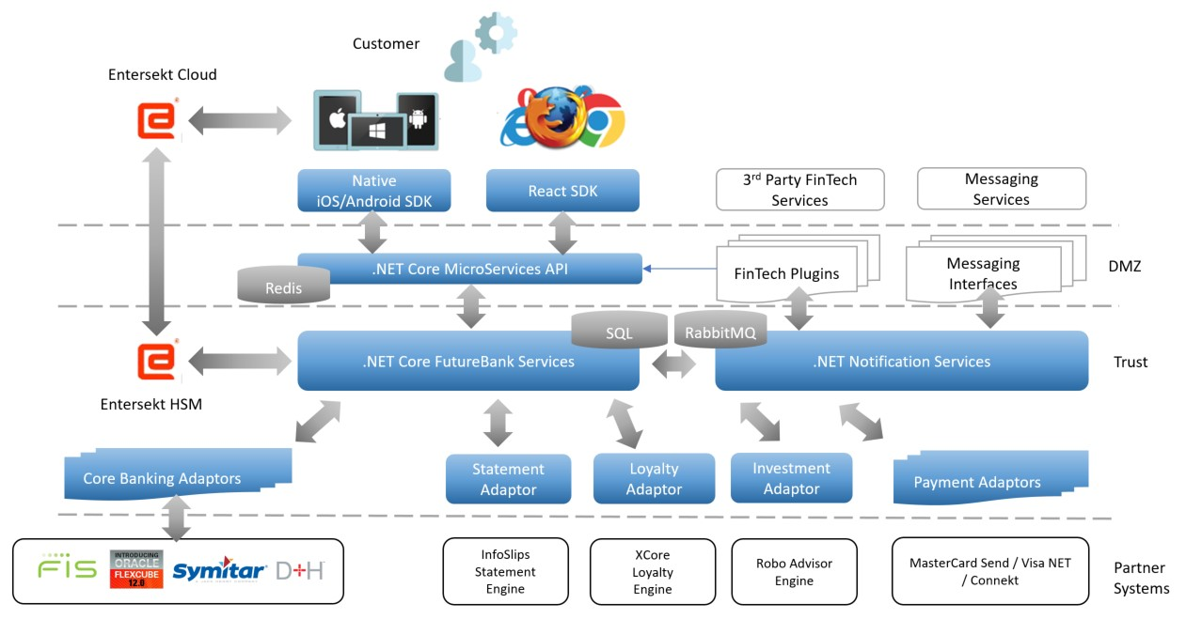 Figure .

: High level platform architecture

* iOS and Android Mobile Applications

Theme-enabled and customizable mobile applications written in Xamarin, Swift and Java, with built in mobile SDKs that integrate with the FutureBank Microservices API and the Entersekt environment for tokenization support.

* Web Application

Theme-enabled and customizable web application written in React JavaScript with supporting React JavaScript SDKs that integrate with the FutureBank Microservices API and the Entersekt environment for tokenization support. The Web Application artefacts are componentized and can be easily extended and customized to support new user experiences and representation of data.

WHITE PAPER - NOVEMBER 2017 7

* Microservices API

A C# .NET Core Micro services framework that abstracts core banking functionality. The framework consists of a library of core banking adaptors for popular core banking systems. Functionality is exposed through an API Gateway that provides end points for each of the following Micro services at scale:

**Authentication:** Deals with all things security related and is powered by patented authentication technology o **Registration:** Manages all things related to on-boarding users such as KYC o **Persona:** Deals with all things related to the specific identity using the platform, be it human or computer o **Account:** Deals with all things related to a store of value o **Banking:** A set of adapters, one for each core banking platform supported o **Payment**: A set of adapters, one for each supported Payment platforms, with a single common interface, including Bill Payments o **Document**: Handles physical, compliance related documentation requirements, such as invoicing, statements and bill presentment o **Investment**: Abstracts the complexities of creating and funding Investment Portfolios o **Messaging**: A deep learning, artificially intelligent service that looks across the platform to provide and respond to conversational content that is contextual

Value Added Features

The library of supported partner systems in the ECBank Platform Marketplace provides additional value-added features to banking environments that have the ECBank Platform installed.

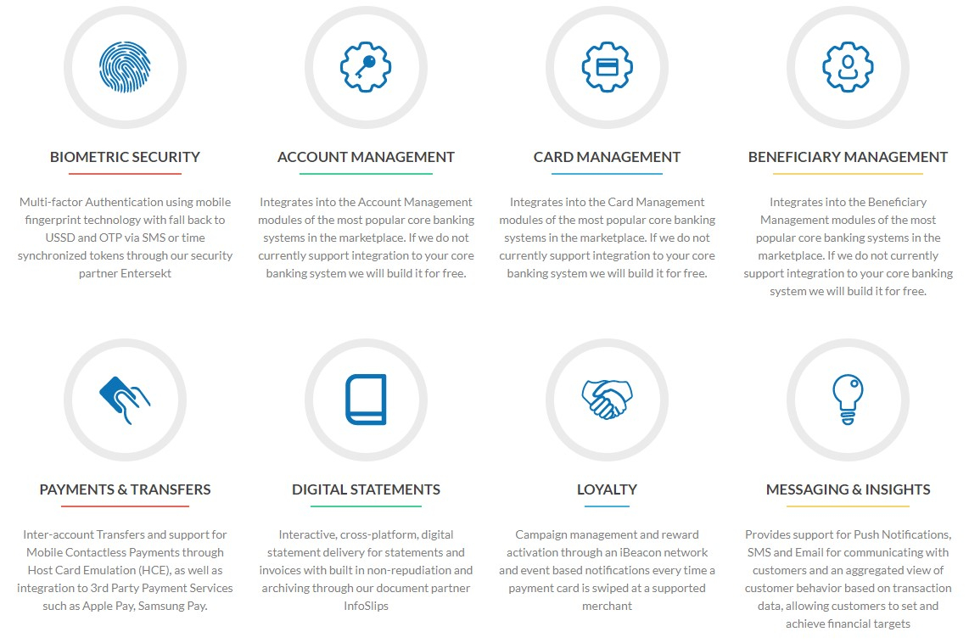

Figure: Value Added Features

### Customizable User Experience

The theme-enabled, extensible and customizable mobile and web applications described above allow accelerated time to market for user experience tailored to a specific financial user journey.

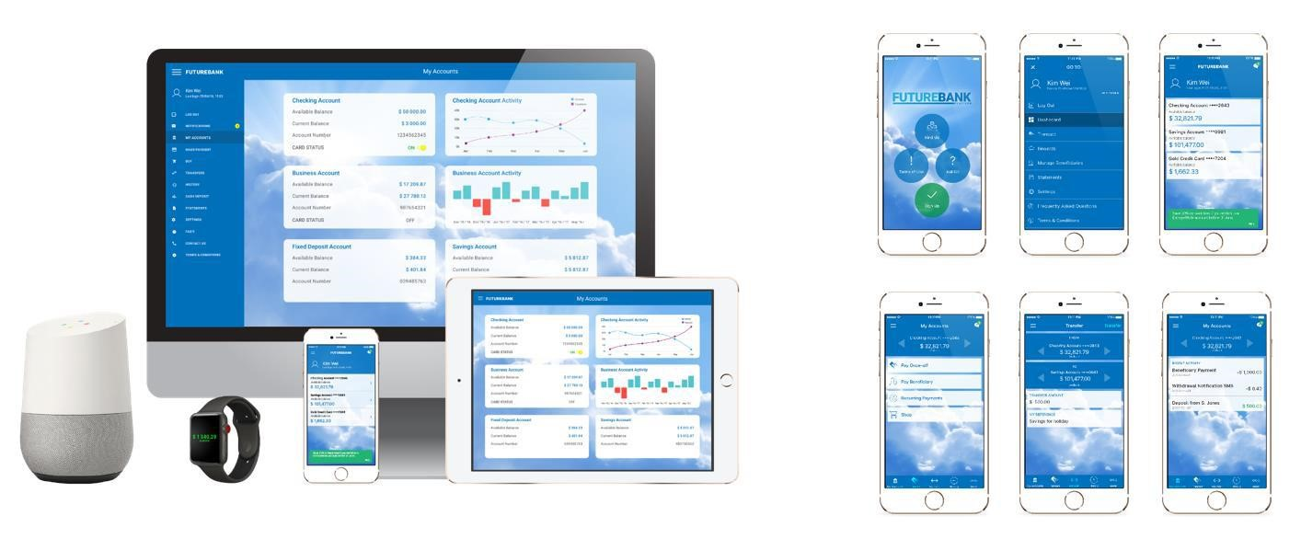

Figure: Customizable User Experiences

## Deployment Model

The diagram below shows the high-level deployment model of the FutureBank Platform within a bank.

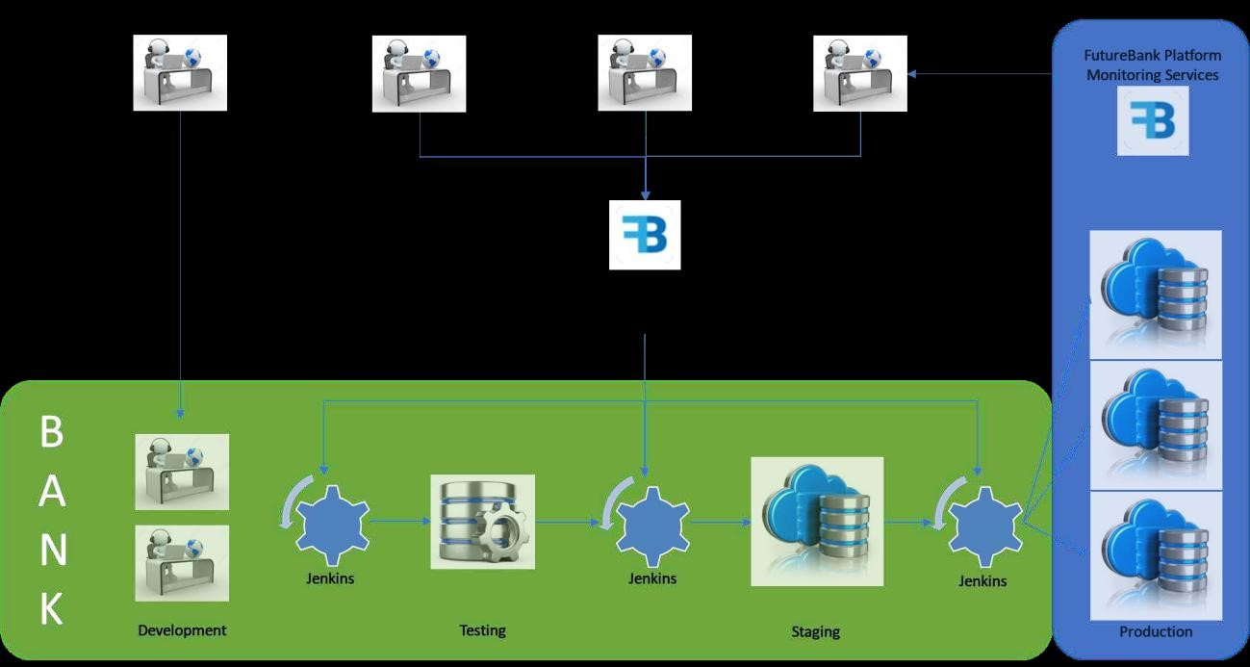

Figure: Deployment Model

The platform is provided to the development pipelines within banks and financial institutions via an update services infrastructure that hosts compatible versions of the Mobile, Web and API frameworks, libraries and adaptors.

Development teams within banks are assisted by ECBank Platform Customization

Teams that provide implementation support. These ECBank Platform

Customization Teams provide technical support to development teams including training, and can also provide additional development capacity if required. In future, software consultancies can become accredited ECBank Implementation Partners and can build their own ECBank Platform Customization Teams as an additional revenue streams. Customization scope can range from extending building new Mobile and Web themes, to building new Microservices to support additional custom integrations with 3rd party systems and platforms. Once the ECBank Platform implementation within a bank has been promoted through the development pipeline and into a Production environment, the ECBank Platform Monitoring Services can start keeping track of each instance and how it is performing and its stability. Feedback is provided to the ECBank Platform Support Team which are responsible for maintaining the uptime of the platform and also for addressing any latent bug fixes required to the platform.

In parallel to the Support Team, the Core Product Team produces core product enhancements to the platform and the Integrations Team adds support for additional core banking or 3rd party platform provider integrations. All of these are published to the ECBank Platform Update Services and made available to development teams that have implemented the ECBank Platform within their development pipelines.

## Summary

The E-office Platform is the ideal open banking platform to help banks quickly and cost effectively meet the demands of the market and the regulators in a secure and customizable way. The following use cases are specific examples of where the E-Office Platform is an ideal fit:

* You are a bank and you need to upgrade your Mobile or Internet Banking

Experience

* You are a bank and you need to expose core banking functionality to 3rd parties via a secure API
* You are a FinTech company and you need to integrate your technology with a bank in a secure and compliant manner
* You have a FinTech product idea and you need to accelerate the development to bring the product to market

E-Office helps Banks leverage off the disruption in the financial technology industry quickly and efficiently in a compliant and secure manner.